Come up with a company or take a well-known existing one and imagine that this company hired you as a network engineer. Design and build a network for this company from scratch.

1. Your design must include a minimum of 2 Cisco 4321 routers, 4 Cisco 2960 switches, and 8 PCs (PCs just as an example of configuration, real network must include minimum 100 hosts, take this into account when creating a network infrastructure).

**Design:**

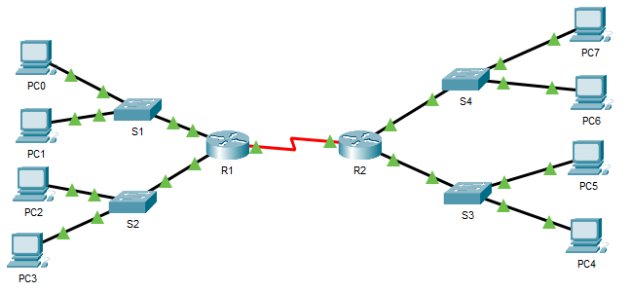

1. Create an appropriate addressing table (subnetting must be included as a part of your addressing scheme, don’t forget about VLSM principles)

**Addressing table:**

|  |  |  |  |  |
| --- | --- | --- | --- | --- |
| Device | Interface | IP address | Subnet mask | Default Gateway |
| R1 | G0/0/0  Se0/1/0  Se0/1/1 | 192.168.10.1  192.168.30.2  192.168.40.2 | 255.255.255.0  255.255.255.0  255.255.255.0 | N/A  N/A  N/A |
| R2 | G0/0/0  Se0/1/0  Se0/1/1 | 192.18.20.1  192.168.30.3  192.168.40.3 | 255.255.255.0  255.255.255.0  255.255.255.0 | N/A  N/A  N/A |
| PC0 | NIC | 192.168.10.2 | 255.255.255.0 | 192.168.10.1 |
| PC1 | NIC | 192.168.10.3 | 255.255.255.0 | 192.168.10.1 |
| PC2 | NIC | 192.168.10.4 | 255.255.255.0 | 192.168.10.1 |
| PC3 | NIC | 192.168.10.5 | 255.255.255.0 | 192.168.10.1 |
| PC4 | NIC | 192.168.20.2 | 255.255.255.0 | 192.168.20.1 |
| PC5 | NIC | 192.168.20.3 | 255.255.255.0 | 192.168.20.1 |
| PC6 | NIC | 192.168.20.4 | 255.255.255.0 | 192.168.20.1 |
| PC7 | NIC | 192.168.20.5 | 255.255.255.0 | 192.168.20.1 |

1. Fully configure the network and use IPv4 and IPv6

**IPv4:**

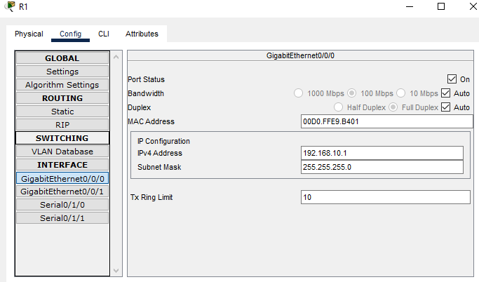

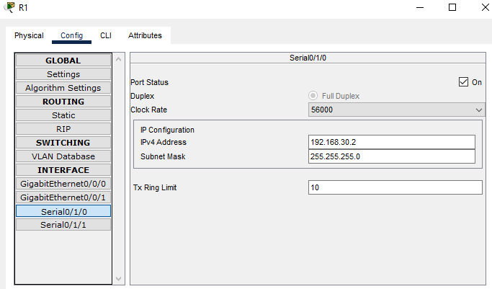

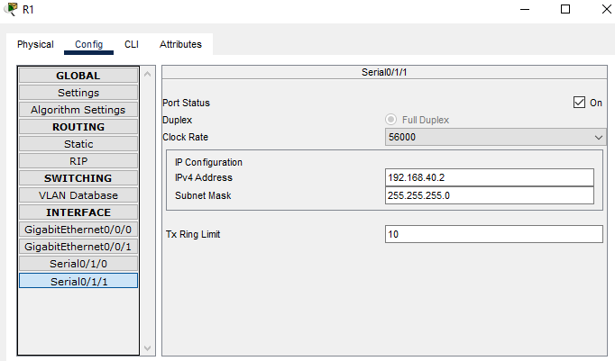

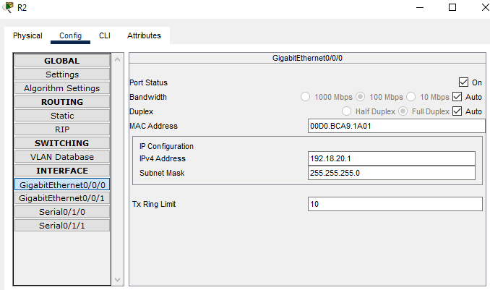

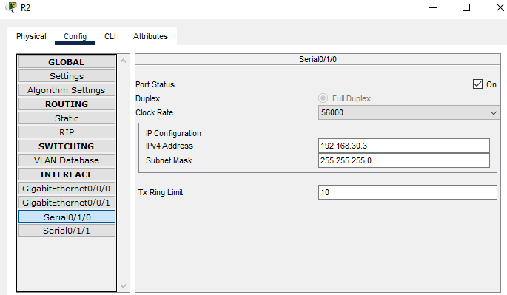

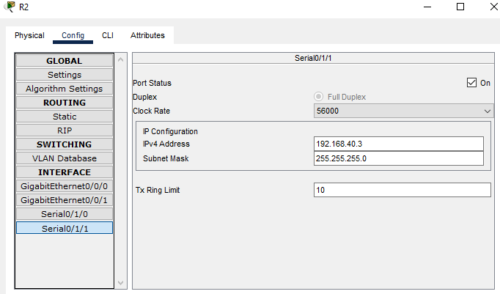

**IPv6:**

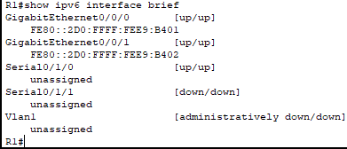

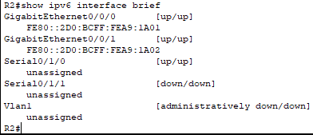

1. Verify the network using at least five show commands.

**1:**

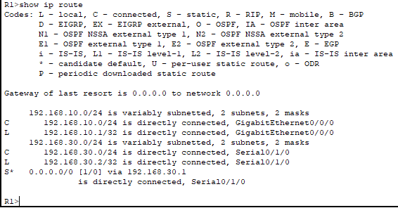

**2:**

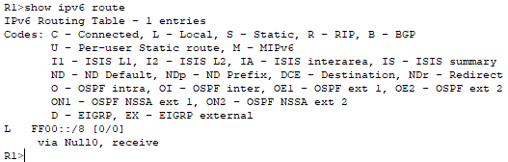

**3:**

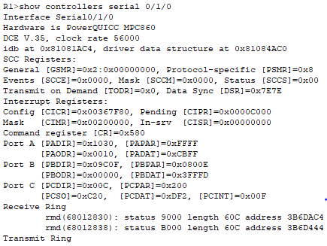

**4:**

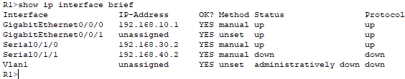

**5:**

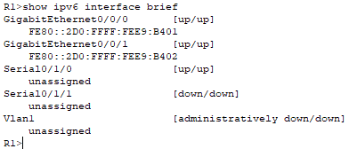

1. Secure the network using SSH, secure passwords and console passwords (minimum).

P.S.: on each router use ip route command in global configuration mode to configure static routing for each serial interface. Also on each serial interface on your routers use clock rate 56000 command.

**SSH, Secure and console passwords:**

